**Database Connection using Microsoft Access**

**Inserting the database into the website**

1. Create the database in MS Access.
2. Locate where the database is saved then **Click and Drag** it to the **Solution Explorer**.

**Creating Add Form**

* Prepare the Webform that you’ll use to add records.
* Example:

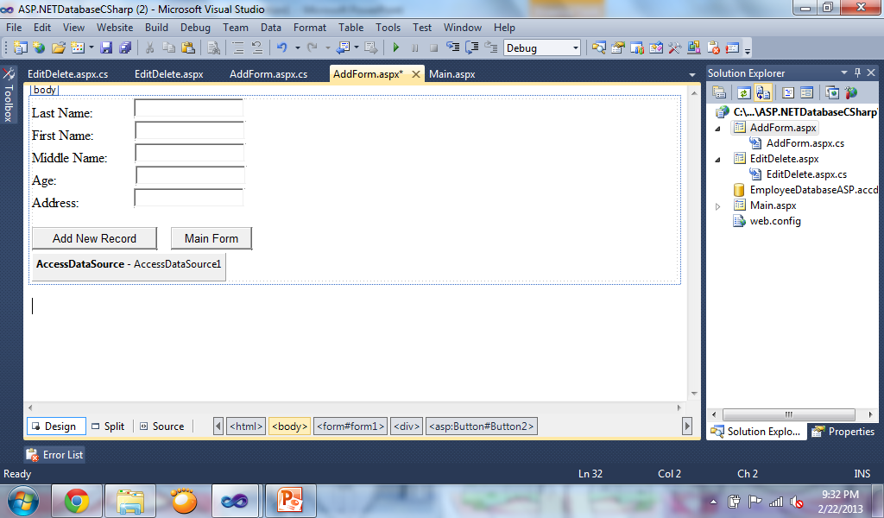

* Add a AccessDataSource Control to the Webform.
* Click on “Configure Data Source” to connect the AccessDataSource using the Connection Wizard.

**“Configure Data Source” Wizard**

* Browse the database you want to connect

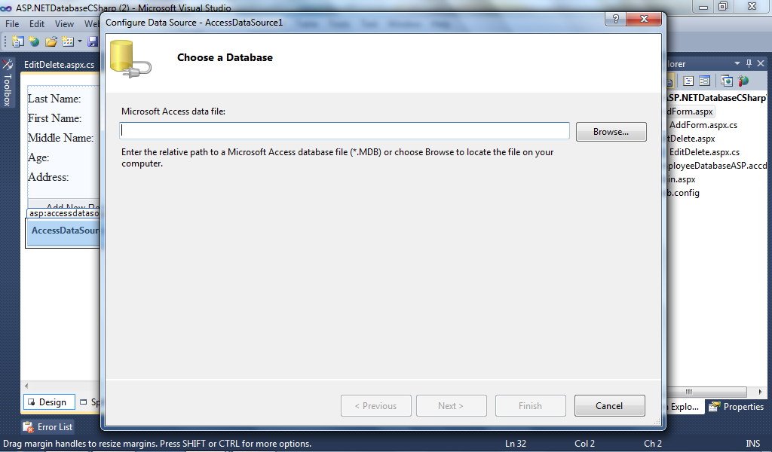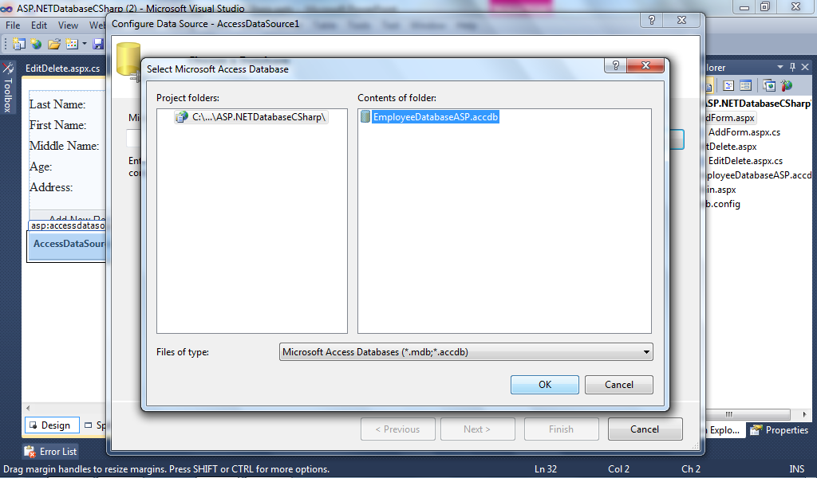

* Click next then choose “Specify columns from a table or view” then select the table name you want to connect

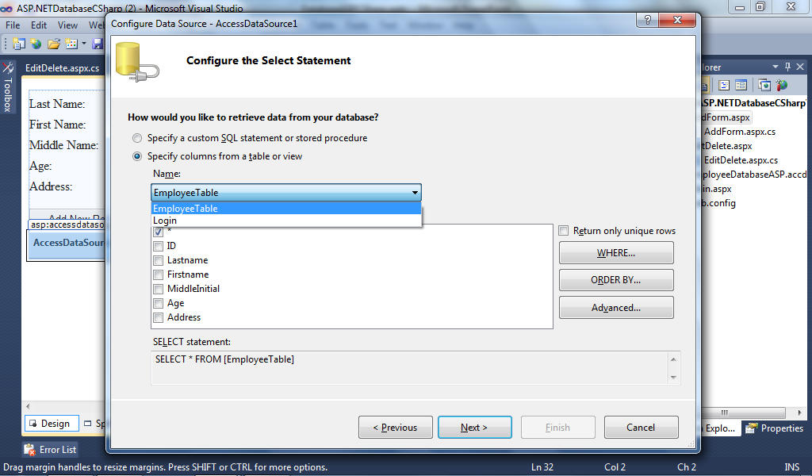

* Click on “Advanced” Button then Check “Generate INSERT, UPDATE, and DELETE statements

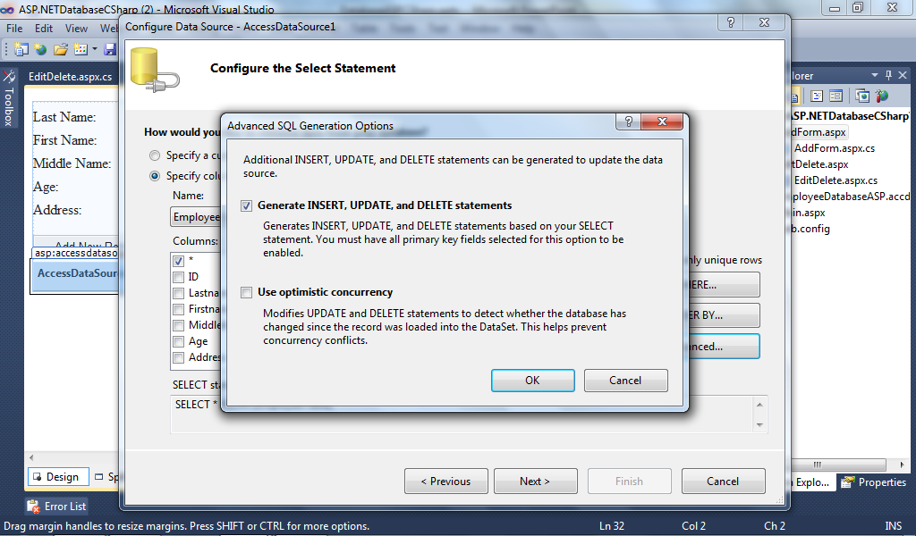

* Click “Next” then click “Test Query” to check the connection of the table then click “Finish”

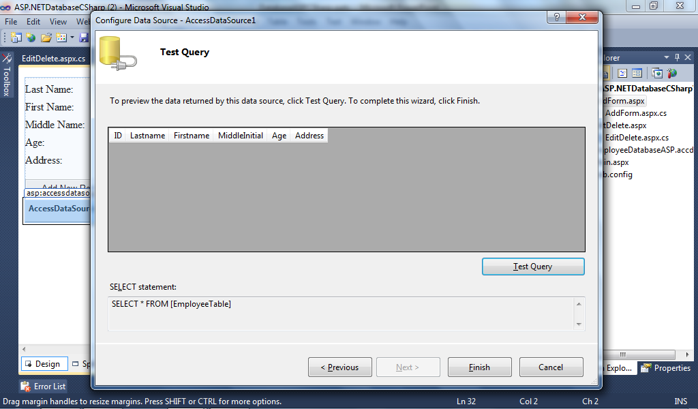

**Code for Adding Records using AccessDataSource**

If IsValid then

AccessDataSource1.InsertCommand = "INSERT INTO EmployeeTable (Lastname, Firstname, MiddleInitial, Age, Address) VALUES ('" + "Ramos" + "','" + TextBox2.Text + "','" + TextBox3.Text + "','" + TextBox4.Text + "','" + TextBox5.Text + "')"

AccessDataSource1.Insert()

End If

**Creating Edit / Delete Form**

* Insert GridView and AccessDataSource into the webform. Configure the datasource of the AccessDataSource. On the GridView, click “Choose Datasource” then select the AccessDataSource. Check “Enable Selection”.

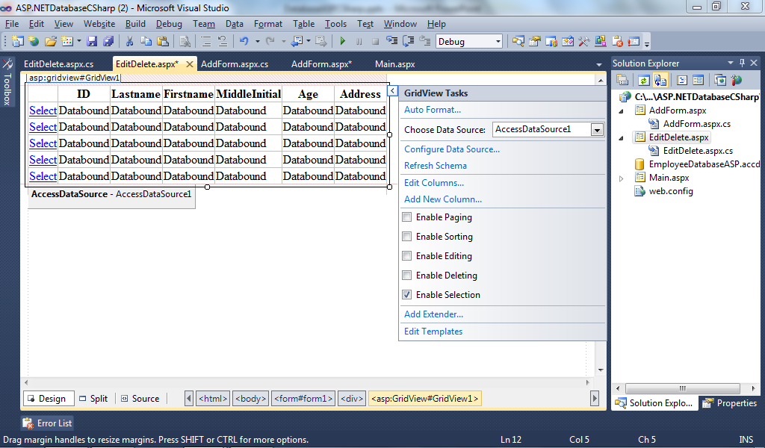

**Sample Form for Edit / Delete**

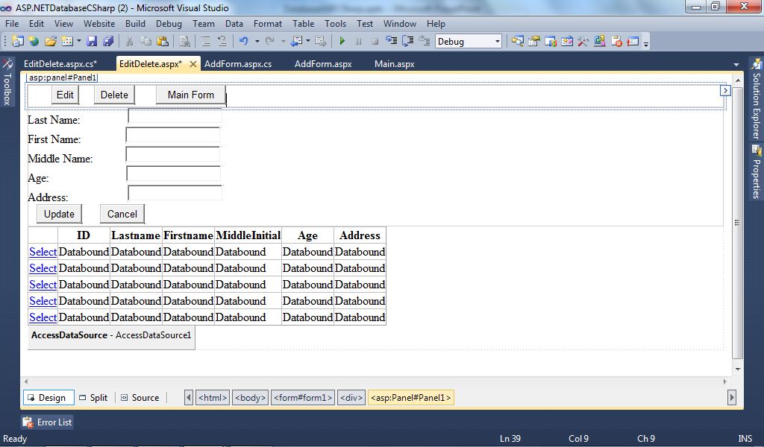

Panel 2

Panel 1

Pan

**Code for Edit Button**

Panel1.Visible = false

Panel2.Visible = true

**Code for Gridview_SelectedIndexChanged**

TextBox1.Text = GridView1.SelectedRow.Cells(1).Text

TextBox2.Text = GridView1.SelectedRow.Cells(2).Text

TextBox3.Text = GridView1.SelectedRow.Cells(3).Text

TextBox4.Text = GridView1.SelectedRow.Cells(4).Text

TextBox5.Text = GridView1.SelectedRow.Cells(5).Text

Session("ID") = GridView1.SelectedRow.Cells(6).Text

**Code for Delete Button**

try

AccessDataSource1.DeleteCommand = "DELETE FROM EmployeeTable " + "WHERE ID=" + Session["ID"].ToString()

AccessDataSource1.Delete()

catch (Exception ex)

End Try

**Code for Update Button**

try

AccessDataSource1.UpdateCommand = "UPDATE EmployeeTable " +

"SET Lastname ='" + TextBox1.Text + "'" +

", Firstname ='" + TextBox2.Text + "'" +

", MiddleInitial ='" + TextBox3.Text + "'" +

", Age ='" + TextBox4.Text + "'" +

", Address ='" + TextBox5.Text + "'" +

"WHERE ID =" + Session("ID").ToString + ""

AccessDataSource1.Update()

catch(Exception ex)

End Try

Panel2.Visible = false

Panel1.Visible = true

**Code for Cancel Button**

* Panel2.Visible = false
* Panel1.Visible = true

**Creating Login Form**

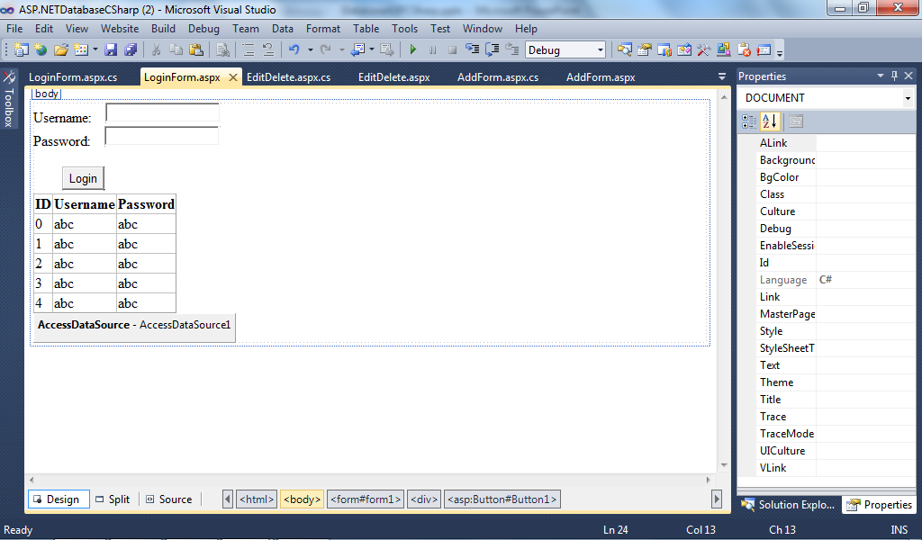

**Code for Login**

* If IsValid Then
* AccessDataSource1.SelectCommand = "SELECT * FROM Login where Username ='" + TextBox1.Text + "' and Password ='" + TextBox2.Text + "'"
* If GridView1.Rows.Count ==1
* Response.Redirect("Main.aspx")
* Else
* Response.Redirect("LoginForm.aspx")
* End If